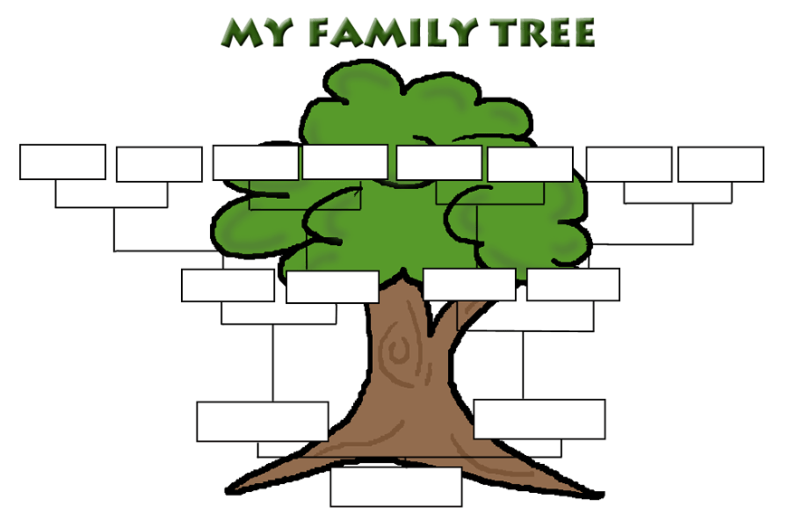
Family Tree Assignment
Due Friday January 29th
- You will record your family tree for the last 3 generations.
  - You/siblings, parents/aunts/uncles, grandparents.
  - Include age, noticeable diseases, cause of death, or anything that sticks out.
- Use 8x11 paper or poster paper.
  - Neat, organized, and presentable.
- Summarize your findings with a 250 word paragraph(s)
  - Typed or hand written.
  - Attach to your family tree.
- Frequently asked questions?
  - What if I am adopted? Record your adopted family.
  - What if I do not know anything about my family? Ask your family.
  - What if my parents do not know anything about my family? Ask the person directly.
  - What if I have step sisters/brothers? You can record them if you like, but are not required too.
  - What if some things are personal health issues and my parents do not want me to share? That is fine, do not put that information down.

